**Abstract:**

Audio classification is a fundamental task in the field of audio processing and machine learning, facilitating a variety of applications such as speech recognition, music recommendation, and environmental sound analysis. This paper presents a novel approach to audio classification using Artificial Neural Networks (ANNs), emphasizing their ability to learn complex patterns in audio data. We introduce a framework that pre-processes raw audio signals into spectrogram representations, which are then used as inputs for the ANN. Our network architecture is optimized through extensive experimentation with various layer configurations and activation functions to enhance classification accuracy. We evaluate the performance of our model on multiple audio datasets, encompassing diverse sound categories and environments. The results demonstrate that our ANN-based model achieves superior accuracy compared to traditional machine learning methods, providing robustness across different noise levels and audio variations. This study not only confirms the efficacy of ANNs in audio classification tasks but also paves the way for future advancements in automated audio analysis systems.

**Modules:**

Design a comprehensive system for audio classification using Artificial Neural Networks (ANNs), the project can be divided into several key modules. Each module handles a specific aspect of the process, from pre-processing audio data to training and evaluating the neural network. Here’s a breakdown of the essential modules for the system:

**1. Data Collection Module**

* **Purpose:** Collects or accesses various audio files needed for training and testing the ANN.
* **Features:**
  + Download or access datasets from public audio libraries.
  + Ensure diversity in audio types (e.g., music, speech, environmental sounds).
  + Handle permissions and data privacy considerations.

**2. Pre-processing Module**

* **Purpose:** Converts raw audio data into a suitable format for neural network processing.
* **Features:**
  + Perform signal normalization to standardize volume levels.
  + Extract features such as Mel-frequency cepstral coefficients (MFCCs), spectrograms, or Chroma features.
  + Segment audio clips into uniform lengths if necessary.

**3. Data Augmentation Module**

* **Purpose:** Enhances the dataset by artificially expanding the diversity and quantity of training data.
* **Features:**
  + Apply techniques like pitch shifting, time stretching, and adding noise to generate new training samples.
  + Ensure augmented data remains representative of real-world scenarios.

**4. Neural Network Architecture Module**

* **Purpose:** Designs and constructs the ANN for audio classification.
* **Features:**
  + Select and implement different types of neural networks, such as Convolutional Neural Networks (CNNs) or Recurrent Neural Networks (RNNs), depending on the complexity and type of audio data.
  + Optimize layer configurations, neuron counts, and activation functions.
  + Implement dropout and regularization to prevent over fitting.

**5. Training Module**

* **Purpose:** Trains the neural network using the processed and augmented audio data.
* **Features:**
  + Manage batch processing and data shuffling.
  + Monitor training progress with metrics such as loss and accuracy.
  + Implement early stopping, learning rate adjustments, and check pointing.

**7. User Interface Module**

* **Purpose:** Provides an interface for users to interact with the system, enabling them to easily classify audio files.
* **Features:**
  + Design a simple and intuitive user interface that allows users to upload audio files and receive classification results.
  + Include visualization of audio features and classification results.

Use Case Diagram

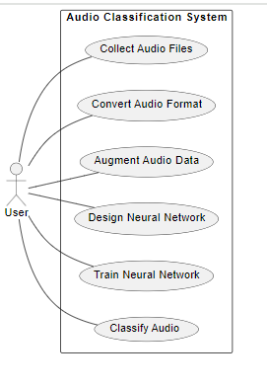

Sequence Diagram

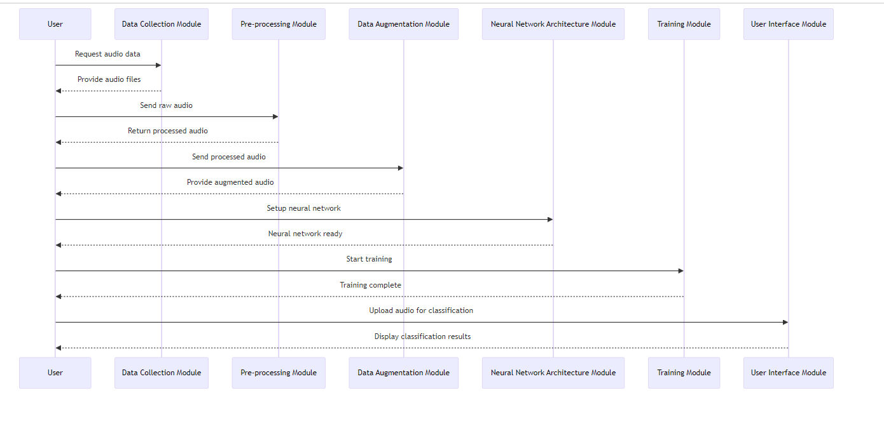

Activity Diagram

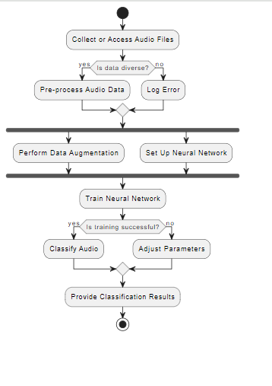

Class diagram

